How to create a virtual machine, deploy rails application and also deploying web application in Azure Cloud services.
1. Login in to Azure Portal and create unbuntu box,
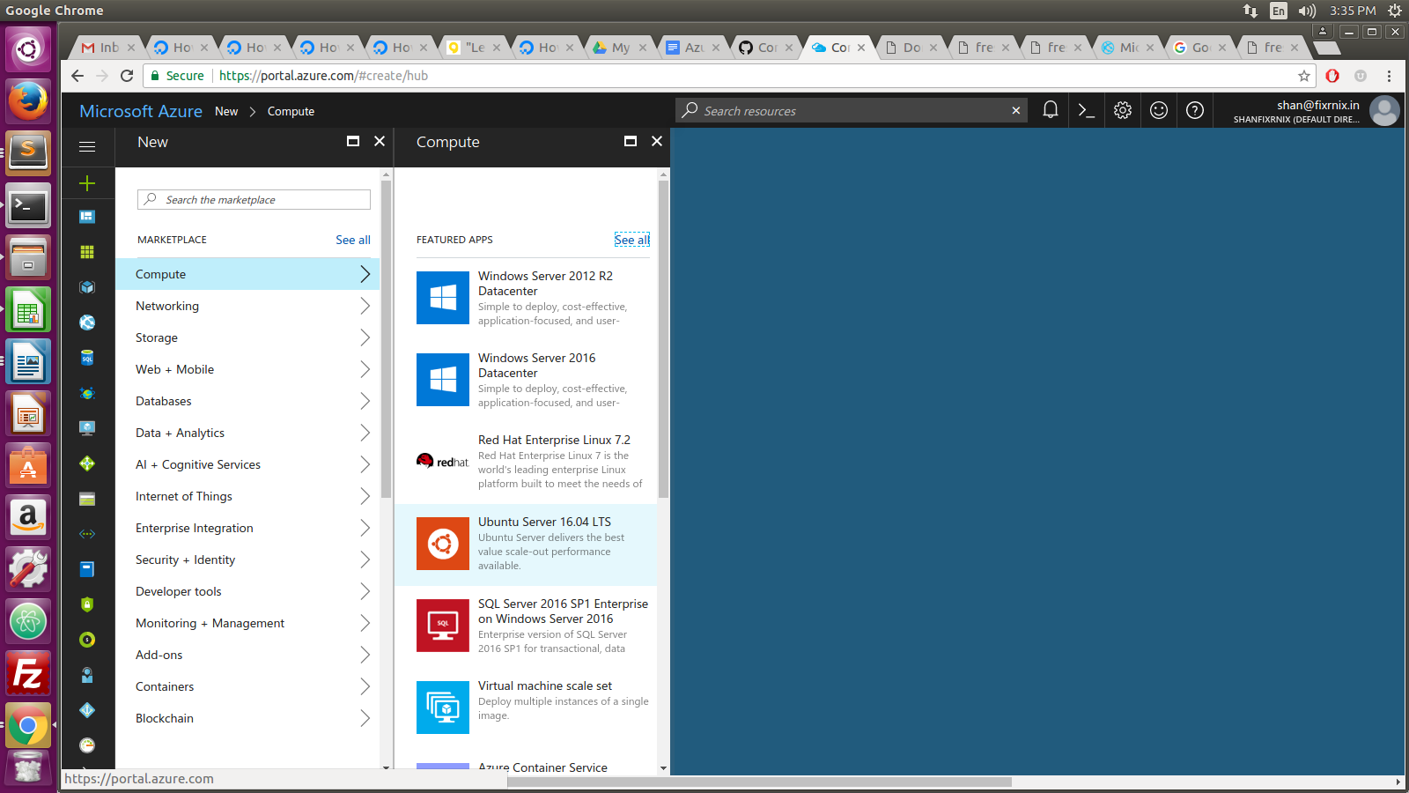
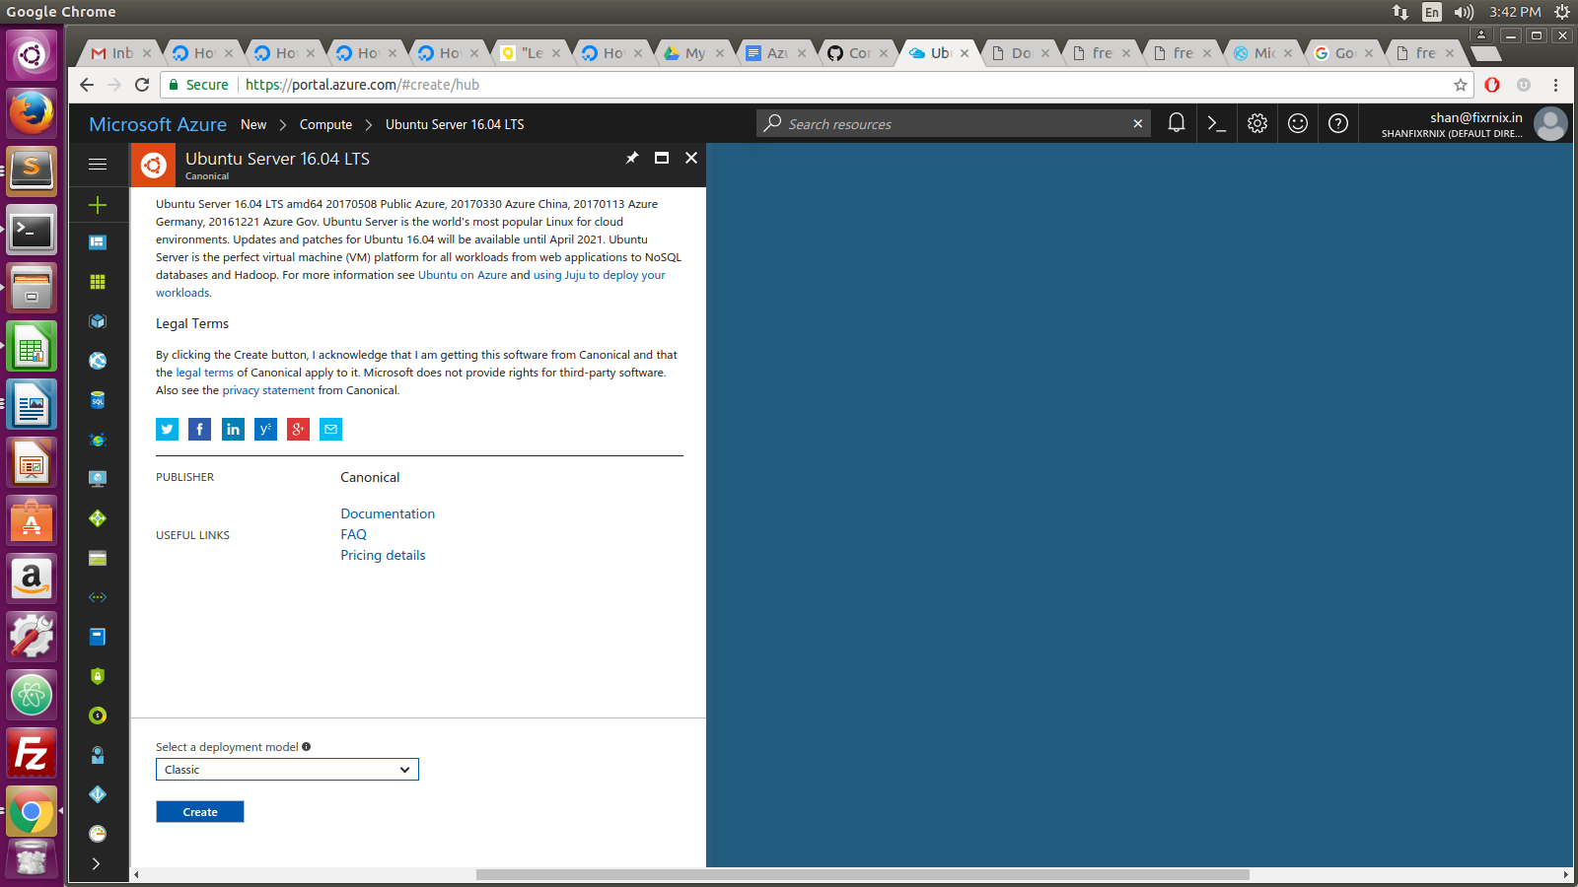
2. Select deploy model as “Classic” and click the create button

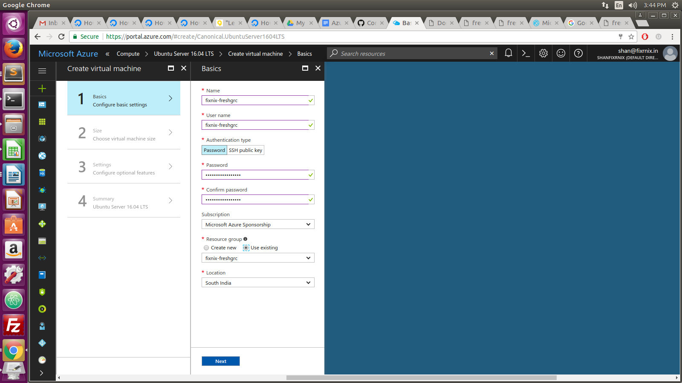
3. Set the username/password for virtual machine
4. Choose the virtual machine size

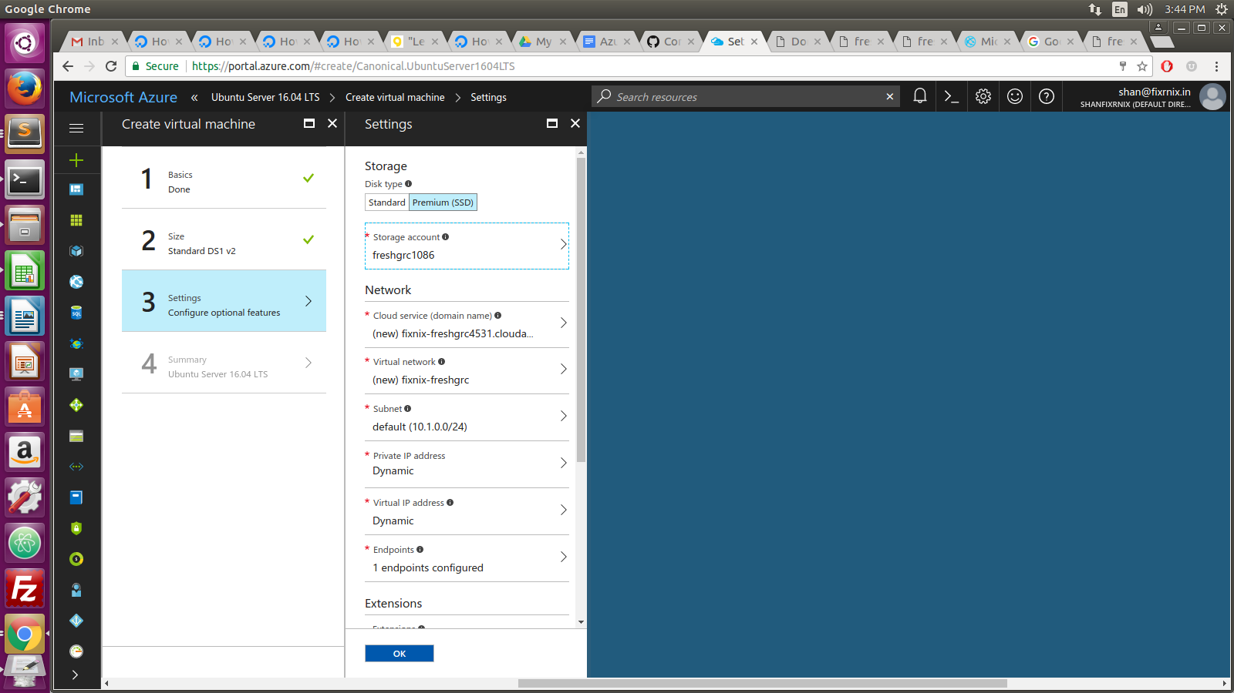
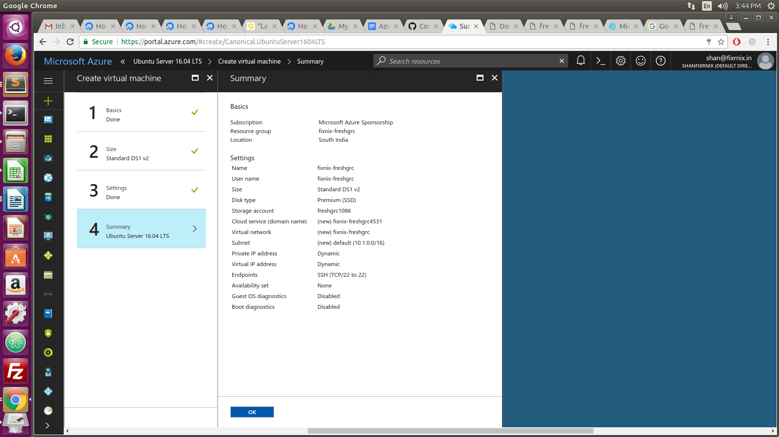
5. See the settings
6. See the summary and click the ok button
7. Deploying the server

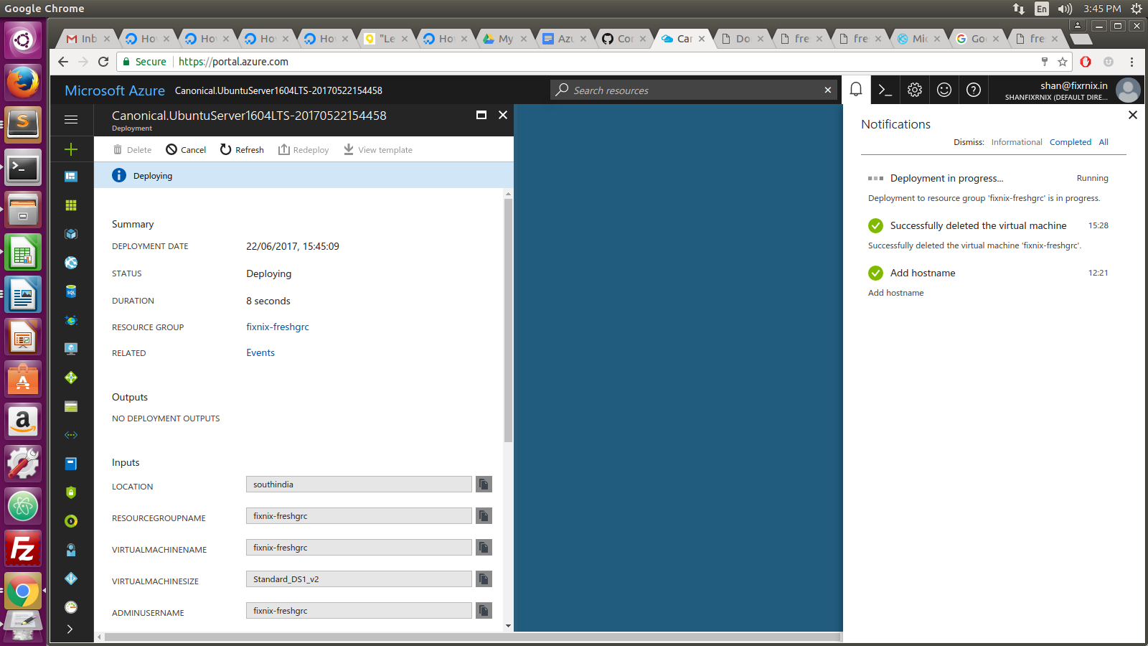

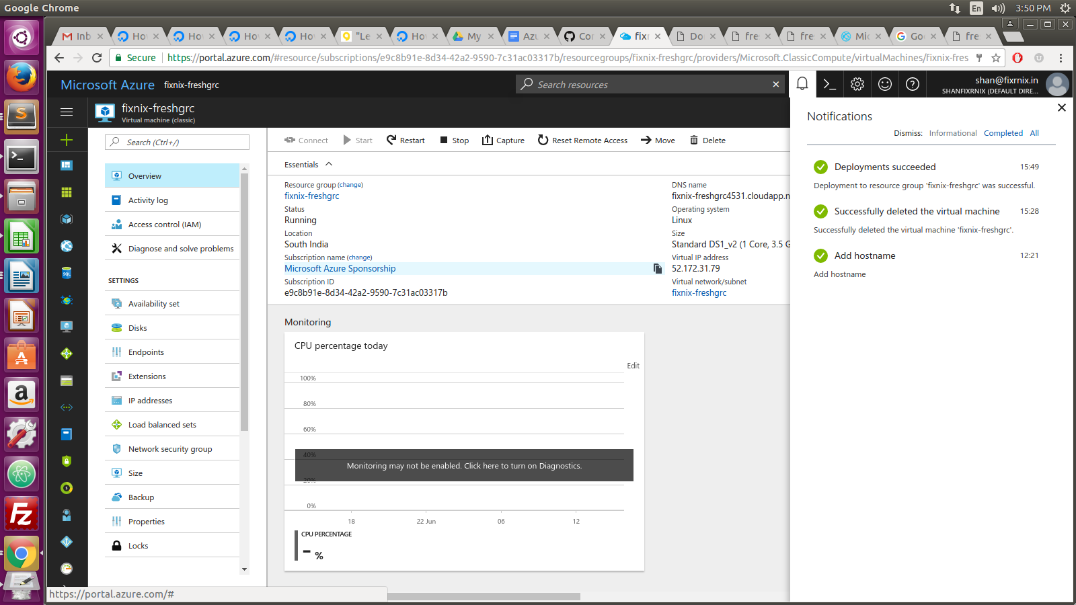
8. Deployment is successfully done

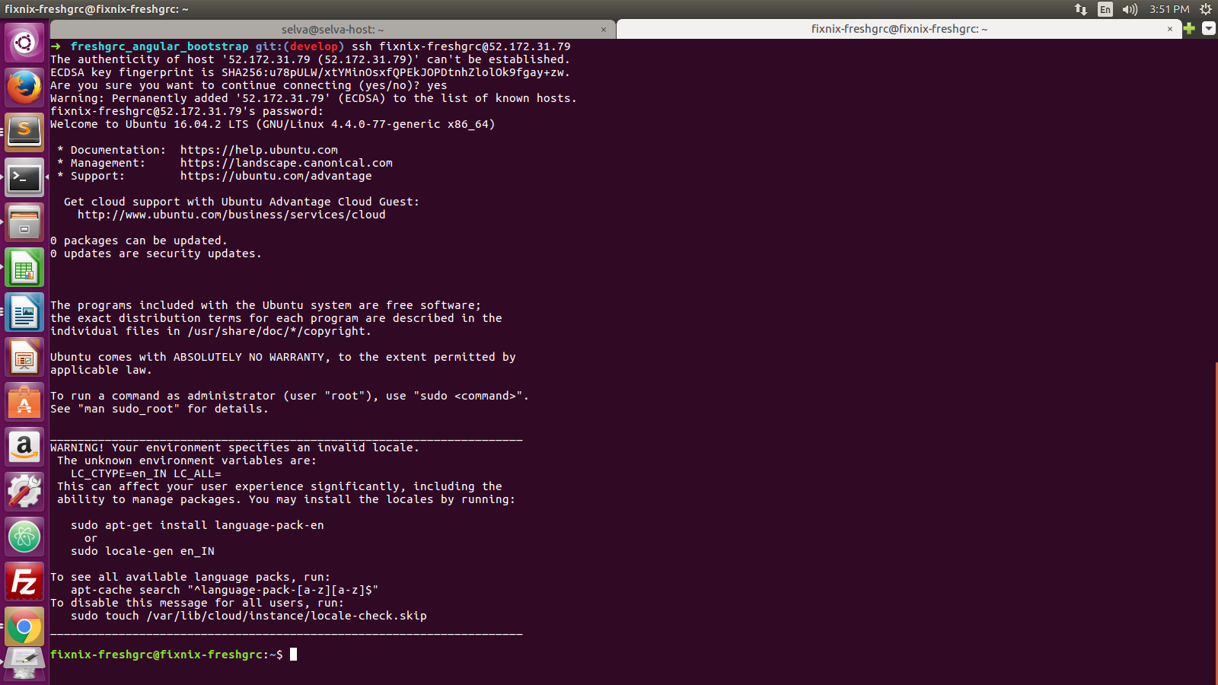
9. Login in to created virtual machine and using the login credentials

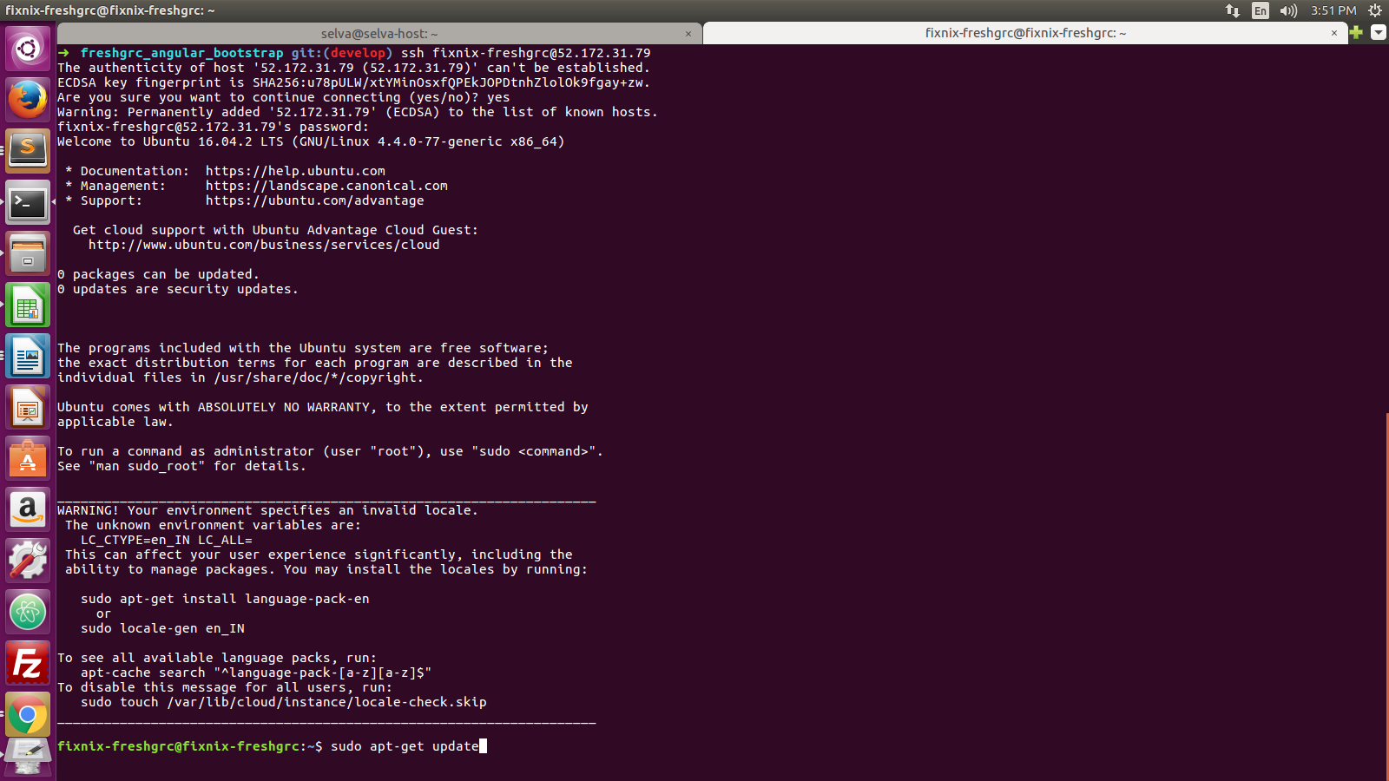
10. Please follow the below command to install ruby and rails

